DIGITAL DESIGN USING HDL LABORATORY (UE18EC206)

EXPERIMENT-6

SIMULATION AND FPGA IMPLEMENTATION OF COMPARATOR USING XILINX VIVADO TOOL

Aim: Write a verilog code to design one bit comparator (dataflow and structural) and 4 bit comparator(behavioural)

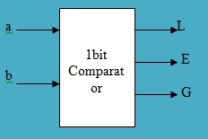
a | b | L | E | G
0 | 0 | 0 | 1 | 0
0 | 1 | 1 | 0 | 0
1 | 0 | 0 | 0 | 1
1 | 1 | 0 | 1 | 0

Dataflow modeling

Structural modeling

Testbench

SCHEMATIC

DEVICE UTILIZATION

SIMULATION RESULT

4 bit comparator Verilog code

Testbench

DEVICE UTILIZATION

SIMULATION RESULT

